## 

World Happiness Report

Harshrajsinh Rathod

Introduction

Happiness is quite a subjective matter which differs from person to person and it’s such a parameter that supersedes all other desires, with in our lives. Mostly all our efforts and desires take us to one underlying goal which is, attaining happiness in life. Here, this report taps into realization of something that is so relevant but difficult to grasp and quantify i.e happiness.

“World Happiness Report” is a milestone survey for the evaluation of global happiness, which surveys 155 countries that are categorized in 10 regions of the world by their happiness levels. This survey was released at United Nations, when there was an event for International Day of Happiness on March 20th. This report is aimed for influencing governments and policy-makers to make decisions, with regards to happiness of the people. Foremost specialists across their fields such as economics, psychology, survey analysis, health, expressed how different parameters of well-being can be utilized to evaluate the development of nations and regions, to assess the happiness of people with in.

Content

The data used for the ranking of the happiness score is derived from the Gallup World Poll, which is based on the answers of the questions pertaining to life. The method for these questions, is called Cantril ladder with in which, respondents are asked to rate their own lives on the scale of 0 to 10, with 0 being the worst possible life and 10 being the best life possible. The data, consisting the columns pertaining the happiness score, is comprised of six factors which are, Economy GDP per capita, Family (Social Support), Health (Life expectancy), Freedom, Trust (Government Corruption), Generosity and Dystopia Residual. These attributes contribute in assessing the happiness scores of various countries, which helps in ranking of happiness with in countries.

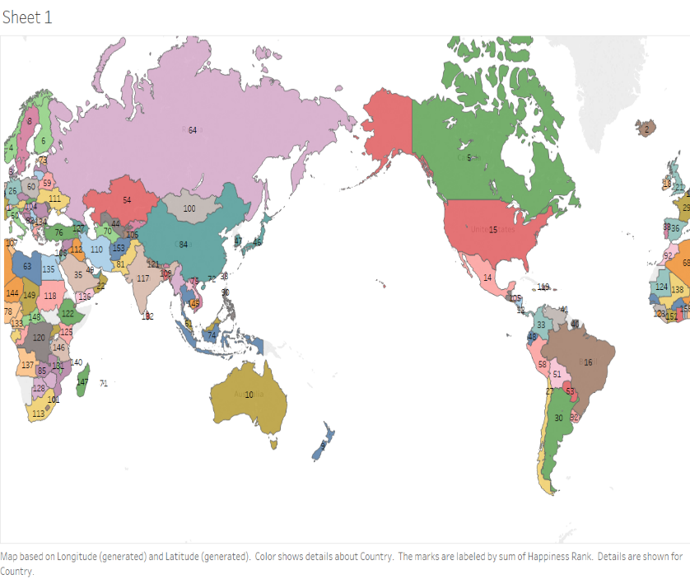

Fig.1. Happiness Ranking of the various countries of the world

The map shown above, in the Fig.1.describes the ranking of the happiness of the world’s various countries. Norway is at the topmost and ranked 1 with in the global happiness rankings for 2017, followed by Denmark, Iceland, Switzerland, and Canada. Here, the ranking ranges from 1 to 155 depicting various countries of the world, which fit in to 10 regions of the world. The countries ranking higher on Happiness Score get ranked higher and the countries with lower Happiness Score get lower Happiness Rank. Thus, Happiness rank is based on the Happiness Score of the respective country. For the Fig.1., the usage of contrasting colours was employed to enhance the division between countries for better navigation and clear distinction.

Page 1

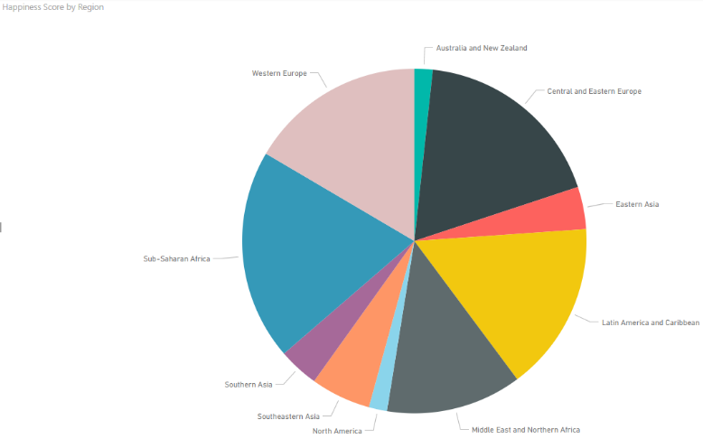

Fig.2. Happiness Score by Region

The Pie chart shown above, depicts “Happiness Score” of 10 different regions of the world which consists of various countries that fit with in those countries. Here, the Happiness Score is assessed with accumulating primary parameters affecting the Happiness Score which are, Economy GDP per capita, Family (Social Support), Health (Life expectancy), Freedom, Trust (Government Corruption), Generosity and Dystopia Residual. Hence, the countries with higher values with in these parameters get higher “Happiness Score”. As evident from the chart, the regions such as, Western Europe, Latin America and Caribbean, Central and Eastern Europe, Sub-Saharan Africa have almost similar Happiness Score, due to their countries which possess higher Happiness Score. Whereas, the regions such as Australia and New Zealand, Southeastern Asia, Eastern Asia possess lower score on the Happiness Score. Ironically, Middle East and Northern Africa fall in middle of the range of the Happiness Score. Here, the use of distinct colors shows the clear distinction between various regions for the better understanding of the Pie chart.

Page 2

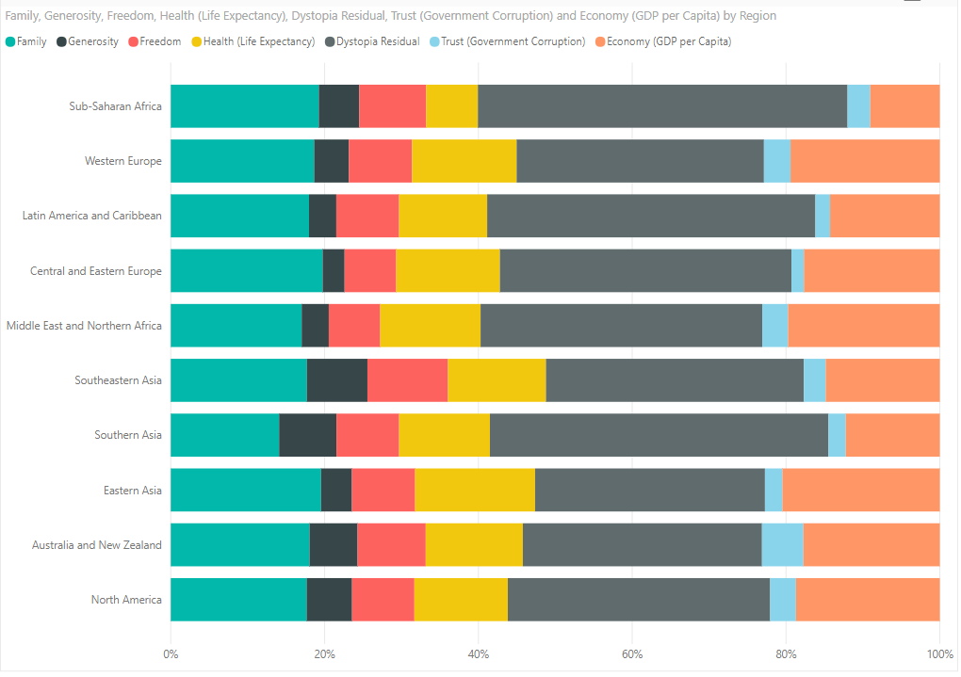

Fig.3. Stacked bar chart for depicting parameters affecting the Happiness Score

The figure above shows, how the different parameters that are accumulated, to form the Happiness Score, of the various regions of the world. As evident from the Stacked bar chart above, Dystopia Residual is the topmost attribute that is affecting the Happiness Score, followed by, Economy GDP per capita and Family. Whereas, Trust (Government Corruption) and Generosity are least affecting parameters that affect Happiness Score. Here, Stacked bar chart neatly describes which regions are being affected by which parameters the most. Here, the distinction of colours is utilized for the clear difference of the various attributes affecting the Happiness

Page 2

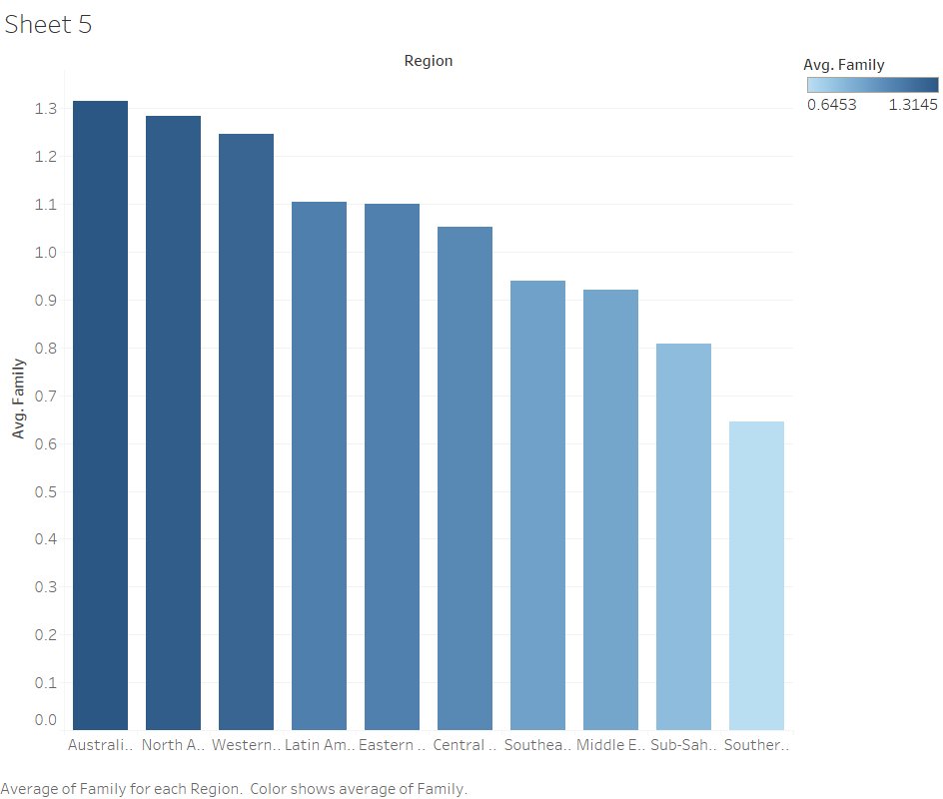

Fig.4. Region and Family Chart

The Bar chart above indicates that Family support received with in the countries of the various regions. As depicted from the graph, Australia and New Zealand is surveyed at the top for the family support score, following by North America and Western Europe. Their averages are so close that minuscule change can change their rankings quite easily. At the bottom, Sothern Asia has the lowest score, comparatively, for the family support. Here, the fading of the colour indicates the low to high shift in the score. Colour Blue is often related with Stability, Trust, Loyalty and calmness. All these values can be associated with Family Hence, Family is best described with the colour blue.

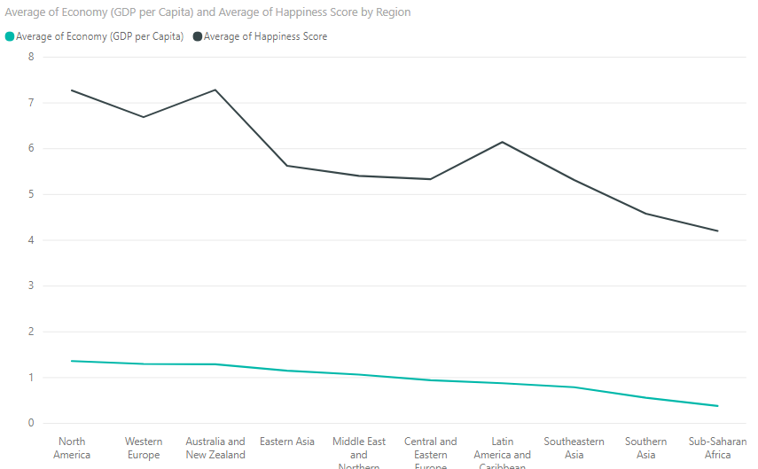

Fig.5. Comparison between Economy and Happiness Score

The line graph comparison signifies, the relationship between Economy and Happiness Score of the various regions. As seen from the graph, Happiness Score varies in accordance with the Economy values quite closely. After Dystopia Residual, Economy is the parameter that affects the Happiness Score the most. Here, to depict the economy, green is used as green has strong relation with safety and money.

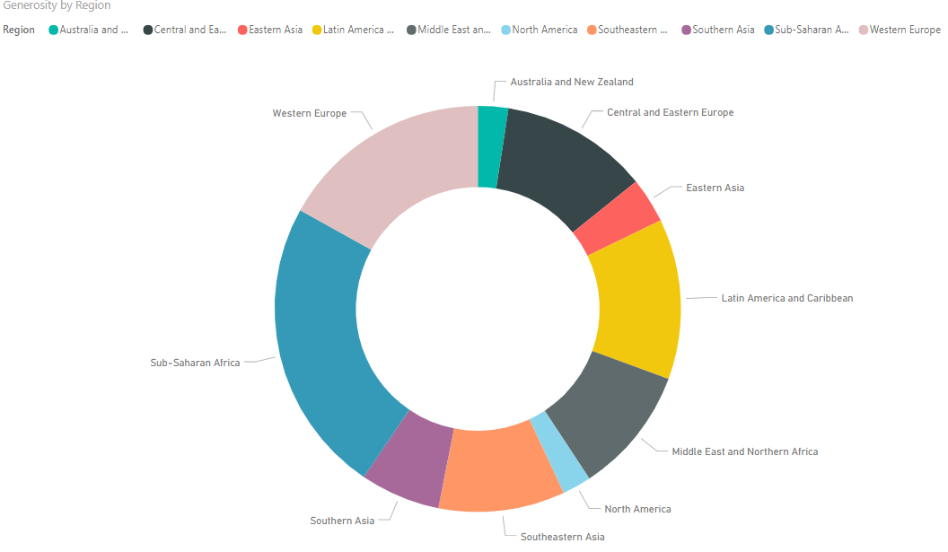

Fig.6. Generosity Score with Region

As seen from the Donut chart, Sub-Saharan Africa is the one with highest generosity score. Whereas, Western Europe, Latin America and Caribbean are on par with each other on Generosity Score. Here, Australia and New Zealand, Eastern Asia, and North America are amongst the lowest in the Generosity Score. The distinction of the colors makes it easy to distinguish between various regions for their generosity score.

Page 3

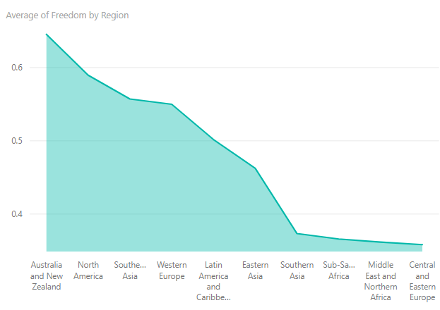Fig.7. Average of Freedom Score by Region

The Area chart displayed above, depicts the decent of the freedom in the various regions of the world. Australia and New Zealand is at the top of the chart, following by North America and Southeastern Asia, to Middle East and Northern Africa and Central and Eastern Europe where Freedom Score seem to be minimum, where the decent ends. Here, the use of cyan color depends tranquility and openness, which are parameters for the Freedom.

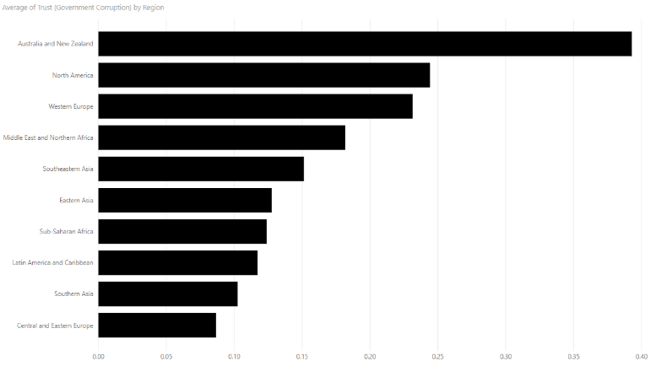Fig.8. Average of Trust (Government Corruption)

As evident from the Bar chart above, the trust of the government based on its corruption in various region is displayed. This trust seems to be highest in the Australia and New Zealand. From this region, trust in government descends to the lowest, in the Central and Eastern Europe. The color black here indicates the corruption as it’s a highly negative attribute which best fits the color black.

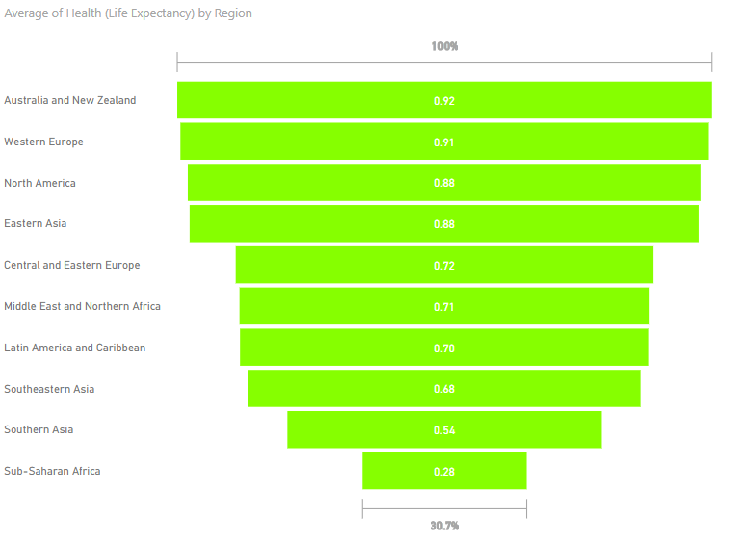

Fig.9. Average of Health Score by Region

The Funnel chart shown above, displays the Average Health of the various countries of the world. As evident from the chart, there’s a decent in health of the world’s regions. The best Health Score seems to be of Australia and New Zealand, following by Western Europe and North America with values respectively 92% and 91%. Whereas, the lowest Health Score is of the Sub- Saharan Africa at only 30.7% of the maximum which is Australia and New Zealand. Here, there seems to be a middle region where there are similar values of the four different regions with their values ranging from 72%, 71%, 70%, and 68%, which is minute difference and almost the same, making them a separate category. Here now, the color green is chosen for the Health Score as it depicts the health and life, as Green is the color of life and rebirth.

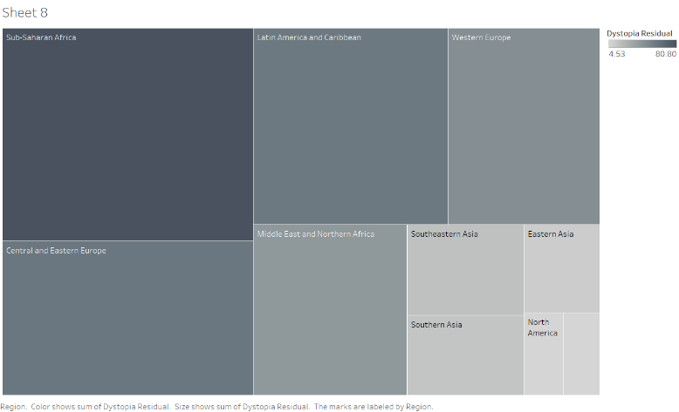Fig.10. Dystopia Residual Score with Region

As shown above, treemap depicts the Dystopia Residual Score of the various region of the world. Here, Sub-Saharan Africa seems to be covering highest Dystopia Residual Score whereas the region Australia and New Zealand is at the lowest for the Dystopia Residual Score. Here, Dystopia means the imaginary country with its population as the world’s least-happy people. The reason for creating Dystopia is to set a milestone, against which all regions of the countries, can be measured making all the attributes as lowest as life in such a country would be quite unpleasant indeed with, world’s lowest economy, lowest health, lowest generosity, most corruption, while having least freedom & social support. It truly displays “Dystopia,” which is in contrast with Utopia. The color dark here shows the gloominess and negativity. The fading of the color shows the lower score in the faded region.

Page 4

Page 4

Conclusion

To sum up, the columns as follows: Economy GDP per capita, Family (Social Support), Health (Life expectancy), Freedom, Trust (Government Corruption), Generosity and Dystopia Residual, shows the range through which they affect the “Happiness Score” contributed too the relevant country. The parameter “Dystopia Residual” is in fact Dystopia Happiness Score (1.85) + the Residual value which indicates the inexplicable value for the countries.

While adding up all these different attributes, the “Happiness Score” can be achieved which in turn makes this model un-reliable to predict “Happiness Score”.

References

Kaggle.com. (2018). *World Happiness Report | Kaggle*.[online] Available at: https://www.kaggle.com/unsdsn/world-happiness [Accessed 18 Feb. 2018].

Worldhappiness.report. (2018). *World Happiness Report 2017 – World Happiness Report*. [online] Available at: http://worldhappiness.report/ed/2017/ [Accessed 18 Feb. 2018].

YouTube. (2018). *Tips and Tricks from a Tableau Jedi*. [online] Available at: https://www.youtube.com/watch?v=CAZ3IAJEuCI [Accessed 18 Feb. 2018].

YouTube. (2018). *Power BI Tutorial For Beginners | Introduction to Power BI | Power BI Training | Edureka*. [online] Available at: https://www.youtube.com/watch?v=gqO0EiCn4cY [Accessed 18 Feb. 2018].

Appendices

Fig.1. The usage of map is done as world’s different countries’ Rankings has to be displayed with in the constrained space, optimally.

Fig.2. The pie chart here is utilized to display and compare portions of Happiness Score, with different regions.

Fig.3. The usage of 100% Stacked bar chart is done to displays constituents of the happiness score, with in one bar, to compare their values against various regions.

Fig.4. Here, the use of bar chart is done because over the same period, changes in Family score of many different regions is to be displayed.

Fig.5. Here, Line chart is being used to compare as Economy is the high contributor to Happiness Score and its correlation can be seen aptly with the help of line chart.

Fig.6. The Donut chart is used for this visualisation, for comparing various portions of the generosity of the various regions.

Fig.7. Here, the use of area chart is done to achieve quantitative progression of the freedom of the various regions.

Fig.8. There is a use of bar chart here because over the same period of time, changes in trust of many different regions is to be displayed.

Fig.9. Here, the funnel chart is utilized to display the stage-wise health deterioration of the regions, to calculate its deterioration by stages.

Page 5

Fig.10. Treemap is used for Dystopia Residual Score because space is constrained, and large amount of hierarchical data needs to be depicted with in that.